**APMS Epics**

Requirements Specification

# Contents

Contents 2

1. Introduction 3

1.1 Purpose 3

1.2 Stakeholders 3

2. Overall description 3

2.1 Functionality perspective 3

2.2 APMS Epics functions 3

3. Functional requirements 3

3.1 Project page interface 4

3.2 View Epics 7

3.3 Create Epic sprint 10

3.4 Add Epics to epic sprint 12

3.5 Create child task to epic 13

3.6 Assign task to Epic in regular sprint 15

3.7 Move epic task from one epic to another epic sprint 16

3.8 Delete Epics 16

4. Use case scenarios 17

4.1 Create Epic sprint 17

4.2 Add Epics in Epic sprint 17

4.3 Add Epics in regular sprint 17

4.4 Assign (move) task from Epic sprint to a regular sprint 18

4.5 Assign (add) task from regular sprint to Epic 18

4.6 Show tasks assigned to Epic 19

4.7 Look at Epic total estimated/used time 19

# Introduction

## Purpose

The purpose of this document is to provide the detailed overview of the Epic functionality as a part of APM system.

## Stakeholders

|  |  |  |
| --- | --- | --- |
| No. | Stakeholders | Goal |
| 1 | Managers | Mark Sprint as epic Sprint;  Create Epic;  Assign tasks to epic;  Move Epic from Epic sprint to another epic sprint |
| 2 | All users | Mark Sprint as epic Sprint;  Create Epic;  Assign tasks to epic; Move Epic from epic sprint to another epic sprint |

# Overall description

## Functionality perspective

The following is aimed to assist users in creating epic sprints and Epics and is a part of APM system. It presents the supplement to the existing system functionalities and relates, specifically, to sprints and tasks management in Agile.

## APMS Epics functions

The managers will be able to perform the following functions:

1. Mark Sprint as epic Sprint
2. Create Epic
3. Assign tasks to epic
4. Move Epics from one epic sprint to another

All users will be able to:

1. Create Epic
2. Assign tasks to epic
3. Move Epics from one epic sprint to another

# Functional requirements

Following are the identified components of the APMS Epic functionality:

## Project page interface

After selecting a specific project, the following page will be displayed:

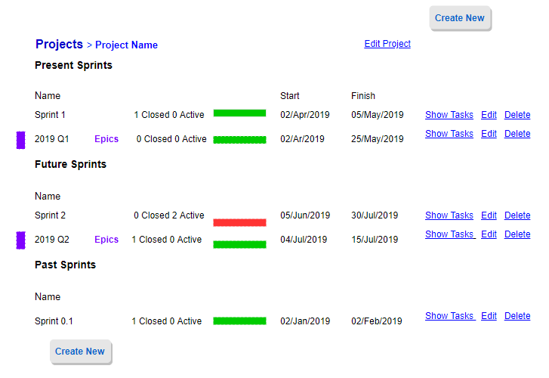

Figure 1. Project page interface

The current project page displays all sprints within this project.

If there are any existing epic sprints, they will be marked with **violet vertical stripe**

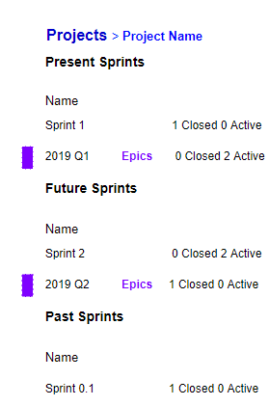

Figure 2. Epic sprint marked

Epic sprint name will contain violet word **‘Epics’** after its sprint name

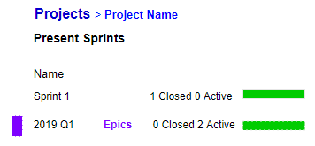

Figure 3. Sprint special marking

The user will not be able to **Delete** sprint if there are Epics in it



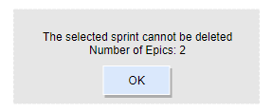

Figure 4. Selected sprint cannot be deleted

If there are no Epics in the sprint, the user will be able to remove it.



After clicking ‘delete’, the user will have to confirm the removal.

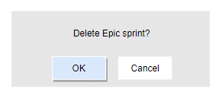

Figure 5. Confirm epic sprint removal

## View Epics

To view all Epics within the epic sprint, the user must select epic sprint (with violet vertical stripe to the left from sprint name) or click **Show Tasks**.

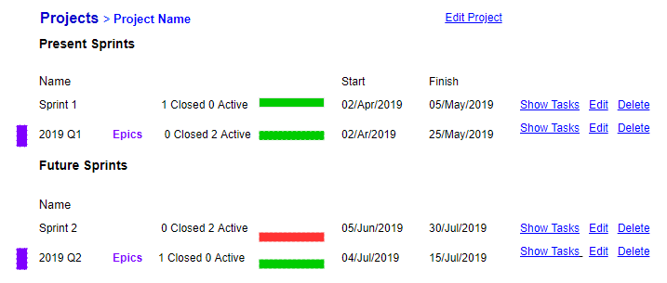

Figure 6. View epics

The epic sprint will display only Epics by default. All Epics will be visually different from usual tasks and will be marked with **violet vertical stripe** on the left

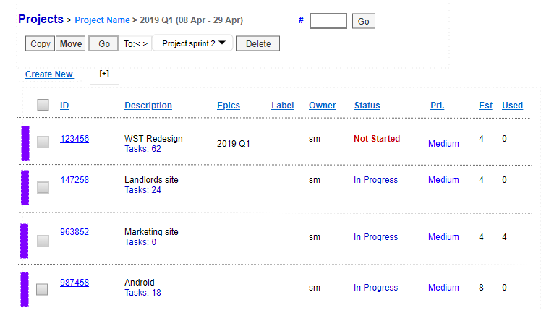

Figure 7. Epics displayed

At the top of epic sprint, the user will be able to click **[+]** to display the children tasks of the Epics in this sprint

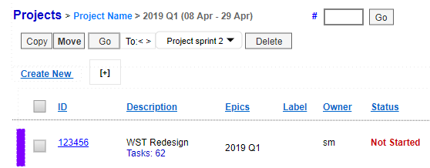

Figure 8. Use [+] to open epics

After the user clicks [+], the system will start loading results. The user will be able to Cancel opening tasks if needed

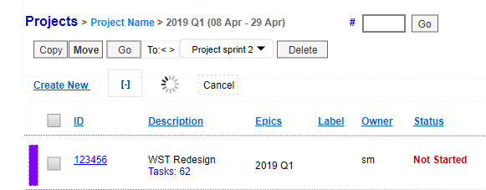

Figure 9. Epics list loading

Now the user can see all children tasks of the Epic:

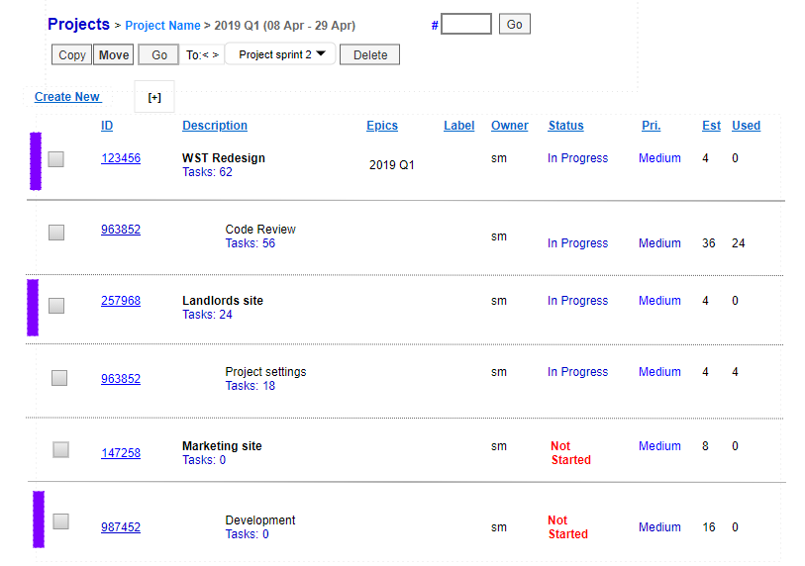

Figure 10. Epics displayed

## Create epic sprint

After the user selects the project, it will be possible to create a new epic sprint and mark it as Epic. To do that, the user must click **Create New**

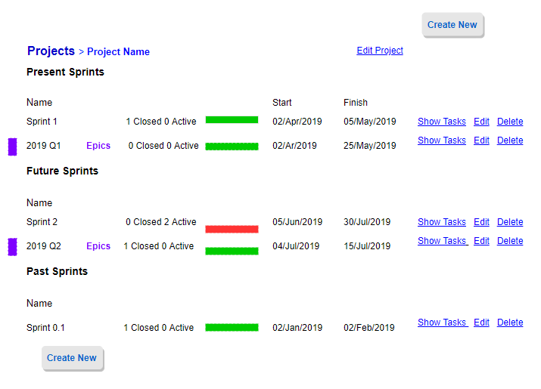

Figure 11. Create epic sprint

In Create Sprint dialog box, it will be possible to **check Epic checkbox** to create epic sprint

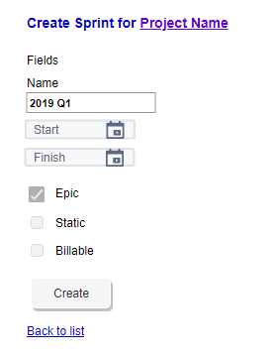

Figure 12. Mark sprint as Epic

After creating the new epic sprint, it will be displayed in the list of Present or Future sprints and marked as **Epics**



## Add Epics to epic sprint

To create a new Epic, the user must click Create New

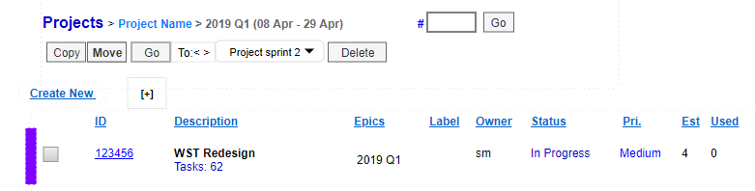

Figure 13. Create new epics

In the ‘create new’ window, the user will enter the required information and will click Submit

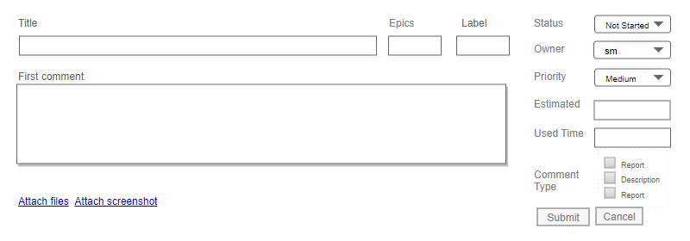

Figure 14. Add Epics form

## Assign task to Epic in Epic sprint

In the epic sprint, it is possible to **assign a child task to Epic**. Select Epic, right click and select **Create subtask**

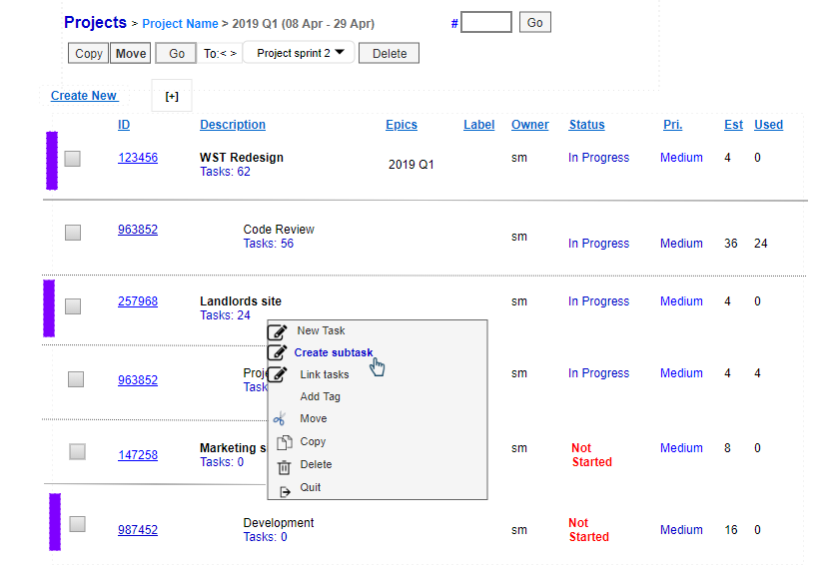

Figure 15. Create subtask

The user then fills in the ‘create new’ window, which is displayed under the selected parent task. Parent Epic will be selected by default.

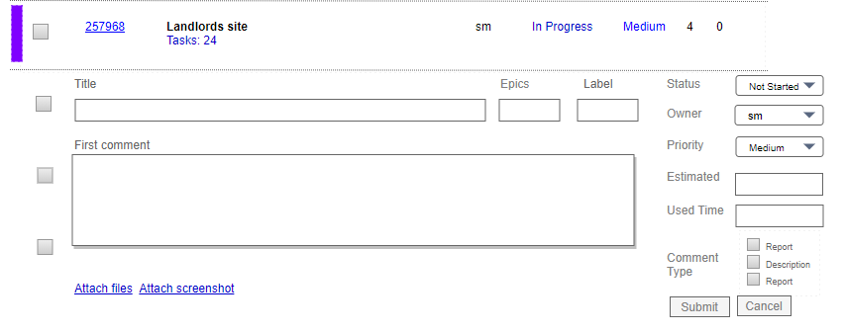

Figure 16. Create child task form

After such activity, the task will get that Epic as parent task



Figure 17. Child task created

## Assign task to Epic in regular sprint

To assign task to epic in regular sprint, the user will open the regular sprint. There will be two options to assign the task to epic in regular sprint.

Option 1. The user will click **Create New.** In the ‘create new’ window, the user will enter the name of Epic to which it will be assigned in the Epics field

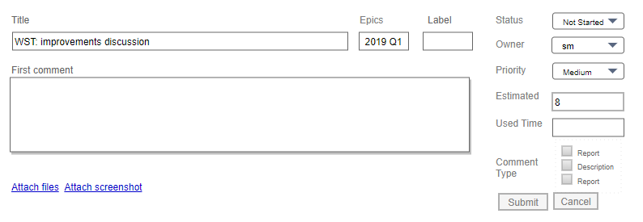

Figure 18. Add epics to regular sprint

After the user clicks Submit, the system will display the new task marked as epic

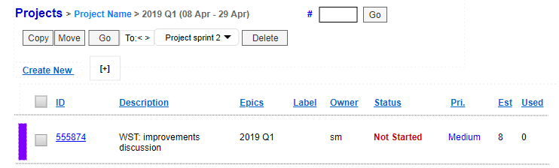

Figure 19. Epics displayed

Option 2. The user will select the existing task in the regular sprint. In the bottom bar next to Copy/Move/Go buttons, the user will select ‘To [Sprint name]’. Then the user will click Move.

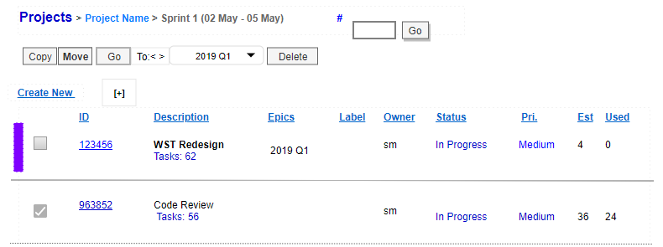

Figure 20. Assign task to epic sprint in regular sprint

The system will move the selected task to epic sprint. It will be marked as epic (**violet vertical stripe** on the left)

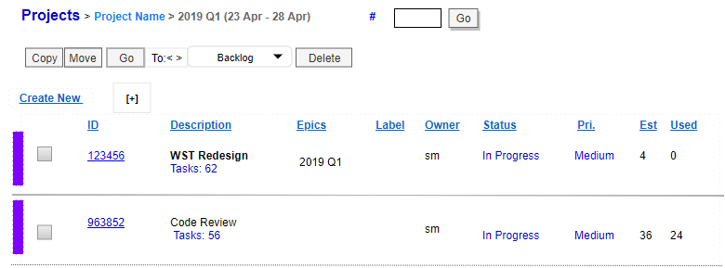

## Move Epic from one epic sprint to another epic sprint

The user will be able to move Epic from epic sprint to another epic sprint.

To do that, the user will select epic. The system will activate **Move** command. In the ‘To’ field, the user will select the epic sprint to which the epic will be moved. Then the user will click Move.

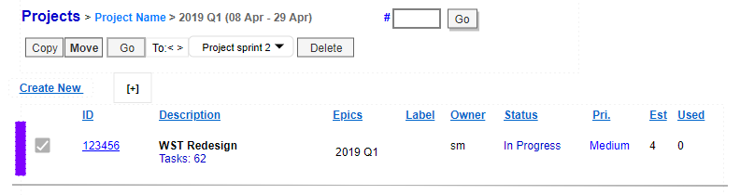

Figure 21. Move task

The system will move the selected epic to the new epic sprint and will display the notification at the bottom of the screen.



**The user cannot move the Epic from epic sprint to non - epic sprint**

## Delete Epic

The user will be able to remove Epic. To do that, the user will select the Epic and click **Delete**. After that, there will be the confirmation dialog with the number of children tasks

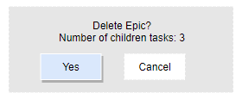

Figure 22. Delete Epics

**After deleting Epics, the children tasks will not be removed. They will not have the Epic assigned to them**

# Use case scenarios

## Create Epic

**Primary actors:** managers

**Goal:** The user wants to create a new epic sprint

**Basic flow:**

The user opens the project.

The user clicks ‘Create New’ button.

The user enters the name of the sprint and selects the date range.

The user clicks (selects) ‘epic’ checkbox to mark the sprint as epic.

The user clicks ‘Create’.

## Add task to Epic in Epic sprint

**Primary actors**: all users

**Goal**: The user wants to assign a child task to Epic in Epic sprint

**Basic Flow**:

The user opens epic sprint.

The user selects the Epic.

The user right clicks and selects ‘Create subtask’ command.

The user fills details in the ‘create new’ window.

The user clicks ‘Create’.

## Assign task from Epic sprint to a regular sprint

**Primary actors**: all users

**Goal**: The user wants to assign a task from epic sprint to the regular sprint

**Basic Flow**:

The user opens epic sprint.

In the field next to “Copy/Move/Go’ buttons, the user selects the regular sprint to which the task will be moved to.

The user selects the task and the system activates ‘move’ button.

The user clicks ‘Move’.

## Assign task from regular sprint to Epic

**Primary actors**: all users

**Goal**: The user wants to assign task from regular sprint to Epic

**Basic Flow**:

The user opens the regular sprint.

The user can select two options to assign task from regular sprint to Epic.

Option 1:  The user opens the regular sprint. Then the user clicks ‘Create New’**.** The user enters the name of Epic to which it will be assigned in the Epics field. The user clicks Submit.

Option 2: The user selects the task in the regular sprint. The user selects the epic sprint to which the task will be moved in the ‘To [Epic name]’ field next to Copy/Move/Go buttons. The user clicks Move.

## Show tasks assigned to Epic

**Primary actors**: all users

**Goal**: The user wants to view tasks assigned to Epic

**Basic Flow**:

The user opens epic sprint (with violet vertical stripe to the left from sprint name).

At the top of epic sprint, the user clicks **[+].**

While the system is loading results, the user can click ‘cancel’ to stop.

## Look at Epic total estimated/used time

**Primary actors:** all users

**Goal:** The user wants to look at Epic total estimated/used time

**Basic flow:**

The user clicks Epic sprint name or clicks Show Tasks.

The user looks at the Epics Est and Used columns.